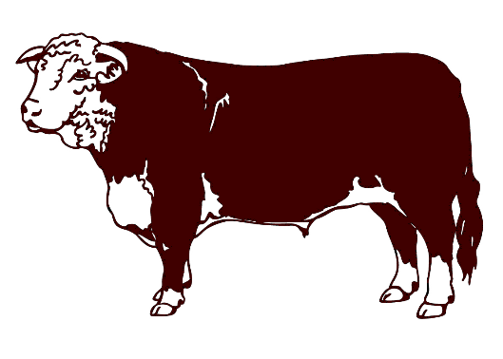
.79/lb. Processing
$80 Harvest Fee
$25 Quartering Fee

BLACK RIVER MEATS, LLC
W11593 Maplehurst lane e
Withee, wi 54498
715-255-7305
Customer Information

First Name: ___________ Last Name: _________________ Cull Date:_________
Street Address: __________________ Phone Number: ____________________
City: _____________ State: _____ E-Mail:__________________________
Zip: __________
Beef Cuts Hanging: _____/_____

Steaks:
- Rib Steak / Ribeye / Prime Rib
(Bone-In) (Boneless) Roast
½” ¾” Thickness
1 2 3 4 per pack
- Sirloin: Bone-In or Boneless
½” ¾” Thickness
1 2 3 4 per pack
- T-Bone & Porterhouse
OR
New York Strip & Filet Mignon
½” ¾” Thickness
1 2 3 4 per pack
*Animals that are 30 months or older will automatically be Boneless New York Strip and Filet Mignon
Round Steak
(Top Round, Bottom
Round, Eye of Round)
½” ¾”
(or hamburger)
1 2 3 4 per pack

Rump Roast & Sirloin Tip Roast
2-3#’s Other:

Roasts: (Mark each style you would like)
- Chuck Roast
- Arm Roast (Pot Roast)
2-3#’s Other:
Ground Beef:
1 OR 2 lb. packages (Circle One)

OTHER: (or hamburger)
- Short Ribs Y or N
- Brisket Y or N
- Flank Steak Y or N
- Skirt Steak Y or N
- Stew Meat 1 OR 2 lb. packages
(Extra $.50/lb.)
EXTRAS: (Check any you would like)
- Soup Bones
- Tongue
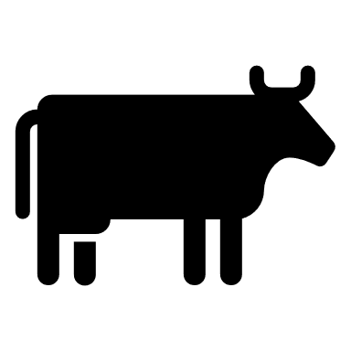
- Heart
- Liver
- Oxtail

